""""""" **Understanding the data** """"""

SHOW COLUMNS FROM sales

SELECT * FROM sales;

DESCRIBE sales;

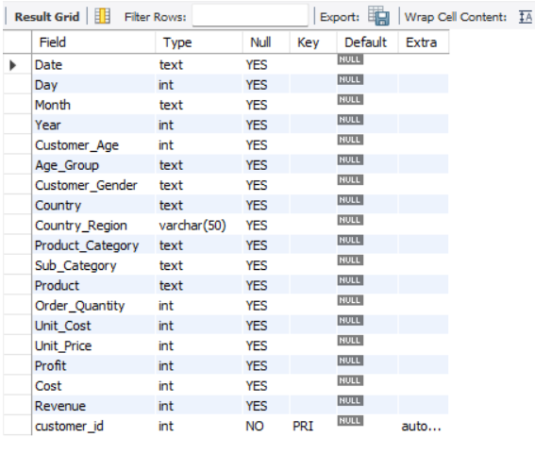

""""""" **Data Preparing** """"""

create table salesbackup as select * from sales

ALTER TABLE sales ADD customer_id INT NOT NULL AUTO_INCREMENT PRIMARY KEY;

UPDATE sales SET Customer_Gender = CASE WHEN Customer_Gender = 'M' THEN 'Male' WHEN Customer_Gender = 'F' THEN 'Female' ELSE Customer_Gender END

UPDATE sales SET Order_Quantity = 0, Unit_Price = 0 WHERE Order_Quantity IS NULL OR Unit_Price IS NULL;

ALTER TABLE sales CHANGE State Country_Region varchar(50);

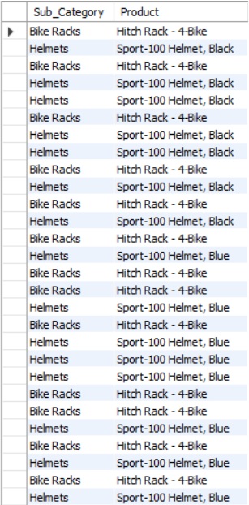

**-- Selecting Specific Customer ID**

SELECT * FROM sales WHERE customer_id IN (1);



**-- Select sales of a 25-year-old customer in Germany on 2013-12-09**

SELECT * FROM sales WHERE date = '2013-12-09' AND Customer_Age = 25 AND Country = "Germany";

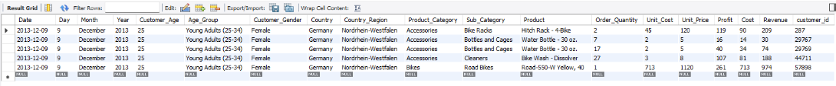

**-- Select 'Road-150' products in the 'Bikes' category**

SELECT * FROM sales WHERE Product_Category = 'Bikes' AND Product LIKE '%Road-150%';

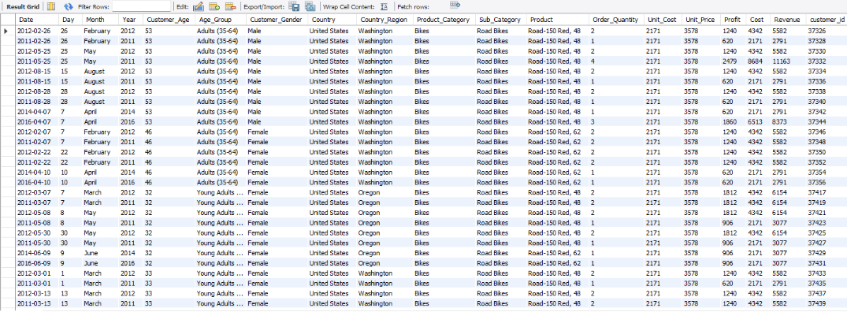

**-- Select sales in Australia, ordered by Order_Quantity in descending order, and limit to the top 10**

SELECT * FROM sales WHERE Country = 'Australia' ORDER BY Order_Quantity DESC LIMIT 10;

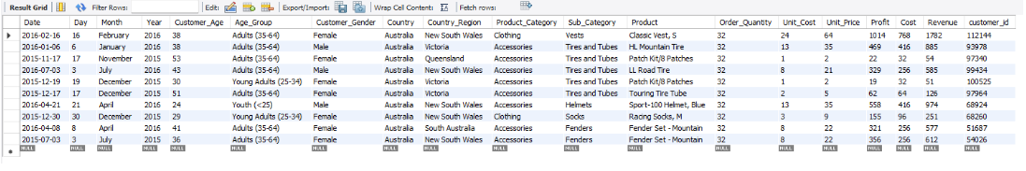

*-- Display the total cost of 'Road-150' products in the United States for 43-year-old female customers

** SELECT Customer_Age, Product, COUNT(Cost) AS Total_Cost FROM sales WHERE Customer_Gender = 'Female' AND Customer_Age = 43 AND Country = 'United States' AND Product LIKE 'Road-150%' GROUP BY Customer_Age, Product;

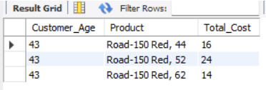

**-- What is the age distribution of customers?**

SELECT Customer_Age, COUNT(*) as Customer_Count FROM sales GROUP BY Customer_Age ORDER BY Customer_Age;

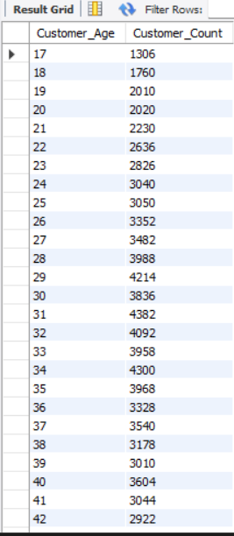

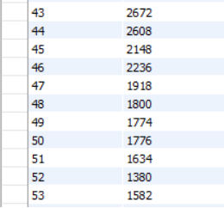

**-- What is the most 5 profitable year?**

SELECT Year, SUM(Profit) as Best_Profit FROM sales GROUP BY Year ORDER BY Best_Profit DESC LIMIT 5;

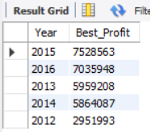

""""""" **Data Analysis** """"""

**-- Select sales in Australia, ordered by Order_Quantity in descending order, and limit to the top 10**

SELECT * FROM sales WHERE Country = 'Australia' ORDER BY Order_Quantity DESC LIMIT 10;

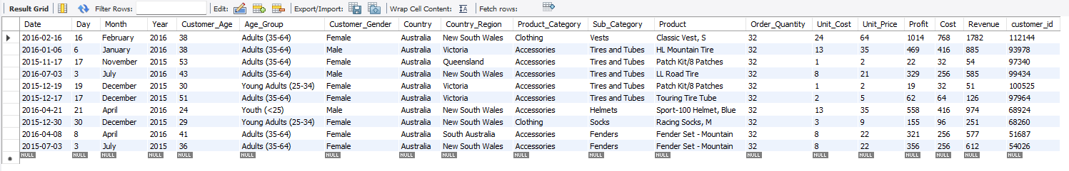

**-- Display the total cost of 'Road-150' products in the United States for 43-year-old female customers

** SELECT Customer_Age, Product, COUNT(Cost) AS Total_Cost FROM sales WHERE Customer_Gender = 'Female' AND Customer_Age = 43 AND Country = 'United States' AND Product LIKE 'Road-150%' GROUP BY Customer_Age, Product;

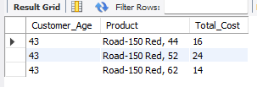

**-- What is the age distribution of customers?**

SELECT Customer_Age, COUNT(*) as Customer_Count FROM sales GROUP BY Customer_Age ORDER BY Customer_Age;

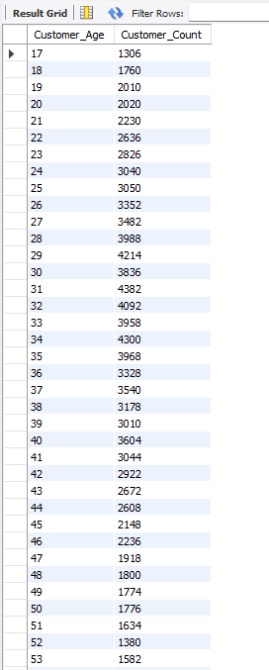

**-- What is the most 5 profitable year?**

SELECT Year, SUM(Profit) as Best_Profit FROM sales GROUP BY Year ORDER BY Best_Profit DESC LIMIT 5;

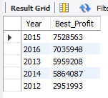

-- What are the 5 most profitable months?

SELECT Year,Month, SUM(Profit) as Best_Profits FROM sales GROUP BY Year,Month ORDER BY Best_Profits DESC LIMIT 5;

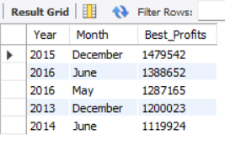

**- Which gender receives the most orders?**

SELECT Customer_Gender, COUNT(*) as Total_Quantity FROM sales GROUP BY Customer_Gender

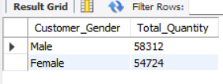

**-- Which 10 countries/country regions earn the highest income?**

SELECT Country,Country_Region, SUM(Revenue) as Total_Revenue FROM sales GROUP BY Country, Country_Region ORDER BY Total_Revenue DESC LIMIT 10;

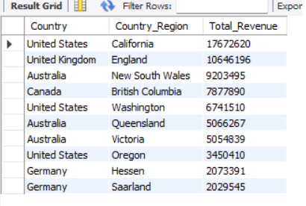

**-- Which 10 categories/subcategories are the most profitable?**

SELECT Product_Category, Sub_Category, SUM(Profit) as Total_Profit FROM sales GROUP BY Product_Category, Sub_Category ORDER BY Total_Profit DESC LIMIT 10;

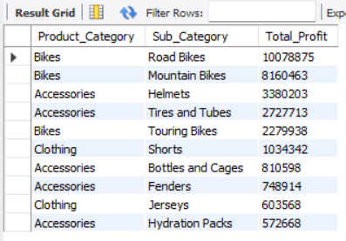

**- Which product categories or subcategories brought more profit?**

SELECT Product_Category, SUM(Revenue) as Total_Revenue FROM sales GROUP BY Product_Category ORDER BY Total_Revenue DESC;

